The Climate Change Project

GROUP 24

# China aims for 'carbon neutrality by 2060 (BBC)

The Problem

From shifting weather patterns that threaten food production, to rising sea levels that increase the risk of catastrophic flooding, the impacts of climate change are global in scope and unprecedented in scale. After more than a century and a half of industrialization, deforestation, and large-scale agriculture, quantities of greenhouse gases in the atmosphere have risen to record levels not seen in three million years. Some nations are focusing on curbing deforestation and boosting renewable energy sources. Others are experimenting with cap-and-trade plans. At stake are hundreds of millions of lives, innumerable species and ecosystems, the health and viability of the economy, and the future habitability of this planet.

Relevance

The global temperature increase can bring disastrous consequences, endangering the survival of the earth’s flora and fauna, including human beings. The melting of the ice mass at the polls, which in turn causes flooding and threatening coastal environments through which small island states risk disappearing entirely. The increased appearance of more violent weather phenomena, drought, fires, death of animal and plant species, flooding from rivers and lakes, the creation of climate refugees and destruction of the food chain and economic resources, especially in developing countries.

Core Questions

“Is Climate Change a Myth?”

“Do you think the government should be concerned about climate change?”

Objectives

* Develop the JavaScript Code for extracting zonal statistics in the GEE (Google Earth Engine) Code editor.
* Extract the Zonal Statistics of the attribute ‘live green vegetation’ at City level as a CSV file.
* Use the Cities- Bengaluru, Delhi, Chennai, Mumbai as your frame of study.
* Calculate the values of live green vegetation in these cities of India.
* Use the zonal statistics (.csv file) extracted to create plots {You can plot them as choropleth maps (One can use Python)} and answer the core questions.

Data

# Use the GEE dataset: MOD13A2.006 Terra Vegetation Indices 16-Day Global 1km (https://developers.google.com/earth-engine/datasets/catalog/MODIS_006_MOD13A2)

# Use <https://github.com/datameet/Municipal_Spatial_Data> for spatial data on cities.

# Help

# Google Earth Engine

Google Earth Engine combines a multi-petabyte catalog of satellite imagery and geospatial datasets with planetary-scale analysis capabilities and makes it available for scientists, researchers, and developers to detect changes, map trends, and quantify differences on the Earth's surface. Google Earth Engine is a geospatial processing service. With Earth Engine, you can perform geospatial processing at scale, powered by Google Cloud Platform.

# Google Earth Engine Code Editor (https://developers.google.com/earth-engine/guides/playground)

The Earth Engine (EE) Code Editor at [code.earthengine.google.com](https://code.earthengine.google.com/) is a web-based IDE for the Earth Engine JavaScript API. Code Editor features are designed to make developing complex geospatial workflows fast and easy. The Code Editor has the following elements: JavaScript code editor, Map display for visualizing geospatial datasets, API reference documentation (Docs tab), [Git](http://git-scm.com/)-based Script Manager (Scripts tab), Console output (Console tab), Task Manager (Tasks tab) to handle long-running queries, Interactive map query (Inspector tab), Search of the data archive or saved scripts, Geometry drawing tools.

Shapefiles (.shp)

The shapefile format is a geospatial vector data format for geographic information system software.

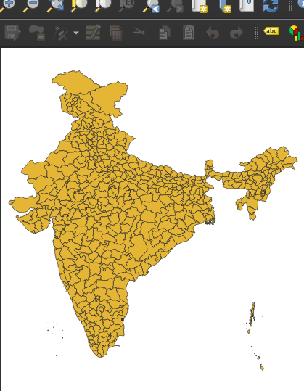

Raster files (.tiff)

A raster consists of a matrix of cells (or pixels) organized into rows and columns (or a grid) where each cell contains a value representing information.

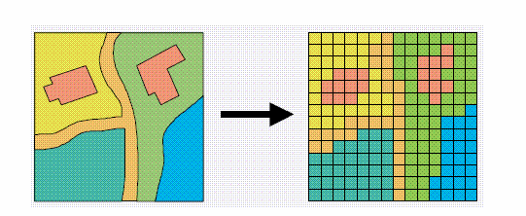

Zonal Maps

A map that depicts land use zones, overlays, or districts.

